## horizontal line



Brick Production Management

Optimization Techniques and Analysis

Submitted to: Dr. Jayaprakash Kar

**─**

Group: A1-G4

Aakanksha Chauhan (16ucs001)

Aanchal Tulsiani (16ucs003)

Ayushi Gupta (16ucs052)

Ishaan Rawat (16ucs079)

# 

# Overview

The project is about brick production and its optimization of various factors using optimization skills and techniques.

# Problem Description

A brick producing enterprise, produces bricks made of special ingredients. The product has applications in dwellings and various commercial, industrial and institutional buildings. A brick is composed of the two parts: cement (C1) and clay (C2), which are cast using the means of products i.e. silicon oxide (P1) and calcium hydroxide (P2) .

In order to minimize the costs of manufacturing, the enterprise limited the availability of the components of brick mass to 56 units of P1 and 54 units of P2.

In order to manufacture the cement for one brick it is necessary to have 8 units of silicon oxide and 9 units of calcium hydroxide and 7 and 6 units, respectively, in the case of the clay. Manufacturing of one brick necessitates 5 units of C1 and 4 units of C2. The cost of unit production is not high, however, as a result of high contribution of defects, the finished products are added a high profit margin. Before the process of manufacturing was started, it was estimated that the production will reach break-even point at the level of sales of 10 pieces. In consideration of the planned production, the enterprise set and assessed the achievement of operating objectives by means of multi-criteria optimization.

Based on the above information provided, optimize the following three different statements:

1. Calculate the minimum investment expenditures for production of one piece of product P, with the unit costs of producing being 2 cash units for cement and 4 cash units for clay.
2. Calculate the maximum profit per product sale with the value of individual components of C1 and C2 at the level of 9 cash units and 7 cash units.
3. Minimize the manpower in production division shifts, with 3 people at each shift participating in manufacturing of cement and 2 people making casts of clay.

# Observation and Formulation

These objectives were listed according to the degree of importance; however, it is known that not all of them can be equally achieved. Definition of decision variables in the form of:

* x1 – level of production of C1 for one product
* x2 – level of production of the product C2 for one product

And, in consideration of the constraint of availability of means of production, the following system of inequalities was obtained:

1. 8x1 + 7x2 ≤ 56
2. 9x1 + 6x2 ≤ 54
3. 5x1 + 4x2 ≥ 10
4. x1 ≥ 1
5. x2 ≥ 1

**Note**: All the values of x1 and x2 should be greater than 1 as each component is necessary for the production of the brick and they should be integers as well, so we’ll have to use **Integer Linear Programming** to optimize the objective equations.

**These constraints are common to all the three Objective Functions.**

## Integer Programming Relaxation Curve for the following 3 objective functions

(The resulting curve from the 5 constraint equations)

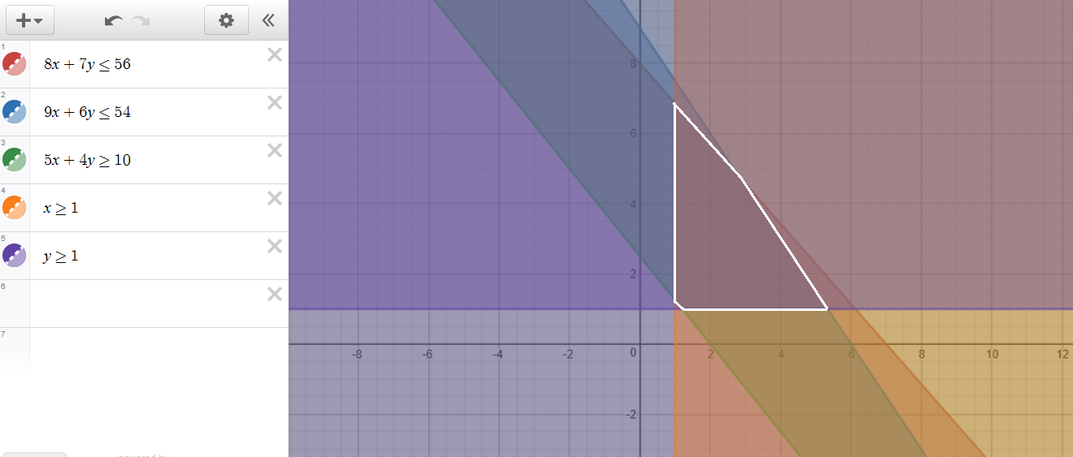

There are 18 possible points which are the interior points of the resulting curve from the constraint equations.

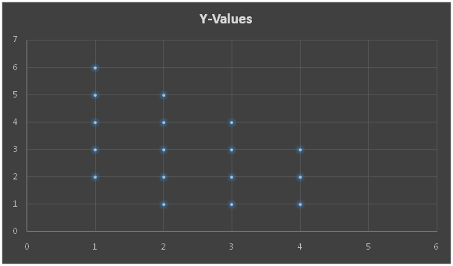

## Minimizing the investment expenditure per product:

**Objective Function**:2x1 + 4x2

**Solution:**

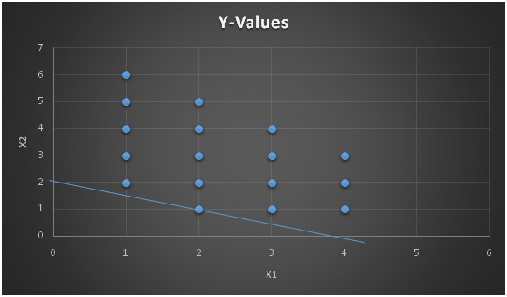

**The MATLAB Code for this objective function is:**

PFA: **OF1.m** (The .m files are available in MATLAB Files folder)

LP: Optimal objective value is 6.400000.

Cut Generation: Applied 1 strong CG cut.

Lower bound is 8.000000.

Relative gap is 0.00%.

### **Optimal Solution:**

x1=2 x2=1 z=8

Minimum Investment per product is 8 cash unit.

## Maximizing the profit per product:

**Objective Function:**  9x1 + 7x2

**Solution:**

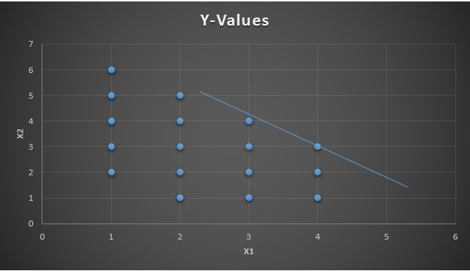

**The MATLAB Code for this objective function is:**

PFA: **OF2.m**

LP: Optimal objective value is -58.800000.

Cut Generation: Applied 3 Gomory cuts.

Lower bound is -57.000000.

Relative gap is 0.00%.

### **Optimal Solution:**

x1=4 x2=3 z=57

Maximum profit per product is 57 cash units.

## Minimizing the manpower in product division shift for one product:

**Objective Function:** 3x1 + 2x2

**Solution:**

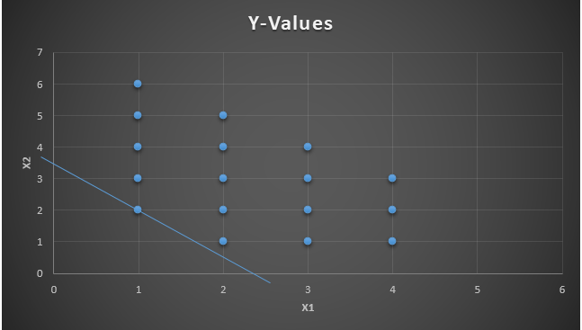

**The MATLAB Code for this objective function is:**

PFA: **OF3.m**

LP: Optimal objective value is 5.500000.

Cut Generation: Applied 1 Gomory cut,

and 1 zero-half cut.

Lower bound is 7.000000.

Relative gap is 0.00%.

### **Optimal Solution:**

x1=1 x2=2 z=7

Minimum manpower per product required is 7 men.

# Conclusion

With the help of MATLAB and Optimization Techniques, we were able to optimize the various factors in a brick production company.